Contact: Andrew Reynolds
Email: renanon@hotmail.com
Phone: 0406277233

Customer Action Plan – djpartybooth

Add Your Info
Customer Name:
Date of inquiry:
Email:
Phone Number:
Customers address:
Billing Address if different from above:
Type of event:
Date of event:
Event start time:
Event end time:
Venue address:
Venue access times:
Venue contact:
Number of Participants:

Wedding Timeline info
Please attach full event time line if applicable.
MC Name:
Bridal Party Entry time:
Bridal party entry song. (Artist and song title):
Couple 1:
Couple 2:
Couple 3:
Maid/Matron of honour:
Best man:

Bride & Groom entry song. (Artist & song title):
Brides name:
Grooms name:
First course time:
Main course time:
Dessert time:

Time of Speeches:
Name of speaker and relationship to bride and groom:
Name of speaker and relationship to bride and groom:
Name of speaker and relationship to bride and groom:
Name of speaker and relationship to bride and groom:
Name of speaker and relationship to bride and groom:
Names of speaker and relationship to bride and groom:

Time of cake cutting:
Cake cutting song. (Artist and song title):
Time of First Dance:
Bridal Waltz Song. (Artist and song title):
Bridal waltz song 2. (Artist and song title):
Song for bouquet. (Artist and song title):
Song for garter toss. (Artist and song title):
Time of farewell:
Farewell song. (Artist and song title):
Farewell song 2. (Artist and song title):
Any other important information:

Photo booth template:
Style: Gold and black template, Grey floral template, Rose gold template, White template. 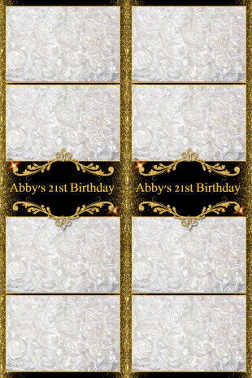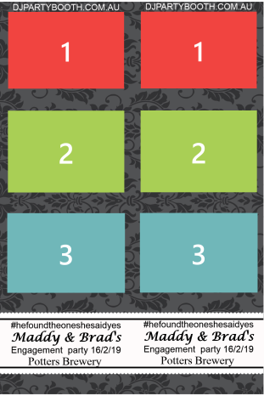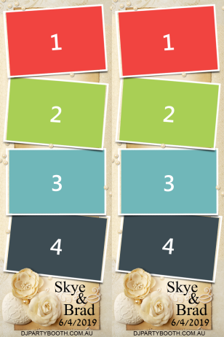 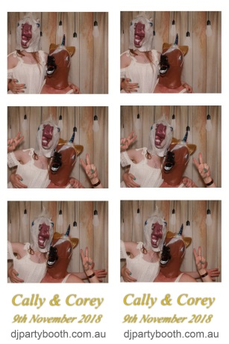
Short Text (e.g. names and date):

Photo booth backdrop:
Please choose one of our back drops if you are booking a Photo booth or let us know if you have your own.
Velvet, white rosette, gold rosette wood and sequins
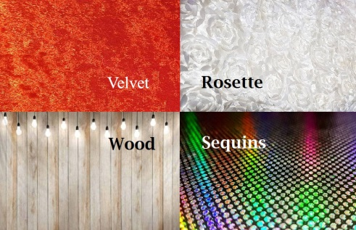

Customer Payment Information
Payments may be made via {cash, paypal, internet banking.}
Preferred payment method: Pay In Person / Pay Online

DJ
Andrew Reynolds
Bsb: 062814
Account Number: 00760462
ABN: 12331993407

Photo Booth
Kimberley Tracy
Bsb: 637000
Acc: 713651001
ABN: 36101836761

Respective to Customers event times.
The total fee for DJ service is $395.00 for 4 hours of entertainment.
The total fee for DJ service is $485.00 for 5 hours of entertainment.
The total fee for DJ service is $575.00 for 6 hours of entertainment.
The total fee for Photo Booth service is $595.00 for 4 hours of entertainment. (PB)
The total fee for Photo Booth service is $395.00 for 2 hours of entertainment. (PB)

MC Service cost start at $50.00 Please contact us if you require MC services.
For DJ Or Photo Booth Customer will pay a booking fee, in the amount of $100.00 at least 3 days prior to the event. This booking fee is non-refundable.
For DJ And Photo Booth Customer will pay a booking fee, in the amount of $200.00 at least 3 days prior to the event. This booking fee is non-refundable.

Additional travel fee of $25.00 for events outside the City of Newcastle. 80 kilometres outside Newcastle is the maximum travel distance for booking.

Customer will pay the balance due on or before the date of the event.

If Customer wishes to cancel the services, Customer must give DJ / PB, at least 7days notice, cancellation after that point will result in balance due immediately.

All Bookings must be confirmed by DJ / PB, 3 days before event.

If Customer requests additional hours, and DJ / PB is able to provide them, the fee will be $90 per additional hour for DJ and be $90 per additional hour for Photo booth.

Setup requirements for DJ:
DJ will require Customer and/or venue to provide: Undercover area with Minimum 2 meters by 3 meters of space for DJ and Equipment, a trestle table or equivalent table, access to venue and room at least 1 hour prior to event and 1 hour after event, suitable parking near venue loading area, access to venue 240v power points for DJ only.
DJ will bring the following for setup: music, DJ Equipment: (2x speakers, 2x stands, wired mic, console and computer, required leads, 2x dance lights).

Music
DJ will take requests from Customer and/or guests of the event, provided that the requested music is in DJ’s collection and/or that time permits. No Downloads at event.

Setup requirements for Photo Booth:
Photo Booth will require Customer and/or venue to provide: Undercover area with Minimum 3 meters by 3 meters of space for Photo Booth and Equipment, access to venue and room at least 1 hour prior to event and 1 hour after event, suitable parking near venue loading area, access to venue 240v power points for Photo Booth only.
Photo Booth provides: Film Strips in 10 Seconds, Unlimited Photo Strips, Props Included with Every Hire, Free Guest Message book, Pro Camera and Printer, 4 Hours Coverage.
Photo booth images will only be kept for 30 days
10% of time booked can be used for maintenance of booth (i.e. restock paper and ink )

Damages
Customer agrees to pay for all damages to DJ / Photo Booth equipment caused by the negligence of Customer or any of the event guests.
No Drinks or Food allowed in, on or near DJ or photo booth tables or equipment.
DJ must inspect the equipment prior to the start of the event to assure it is all in working order and free from any damage.
Customer agrees to all above terms and conditions on deposit.

